**DEPLOYING A WEB PAGE THROUGH GENI AND CLOUDLAB**

**CLOUD COMPUTING LAB-1 Assignment**

**MAIN OBJECTIVE:**

**Task-1:** Getting access to GENI and CloudLab.

**Task-2:** Steps to deploy a simple web page on the cloud.

**Task-3:** Showing the execution of the web page from the local web browser.

**Task-4:** Describe 1) lessons learnt, 2) fun/difficult parts, 3) comparisons between GENI and CloudLab.

**Task-1: Getting access to GENI and CloudLab.**

1) Getting access to GENI:

a) Logged into the GENI portal using UMKC ID.

b) Joined Cloud computing project and added a slice to the project.

c) Added resource “Kansas InstaGENI” to the slice and requesting GENI to reserve the resource.

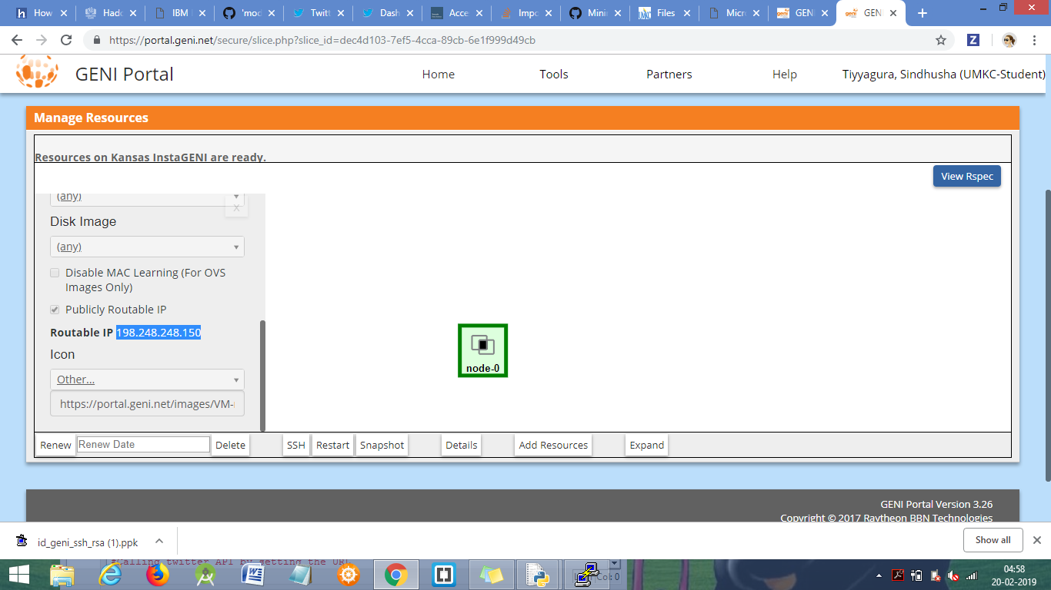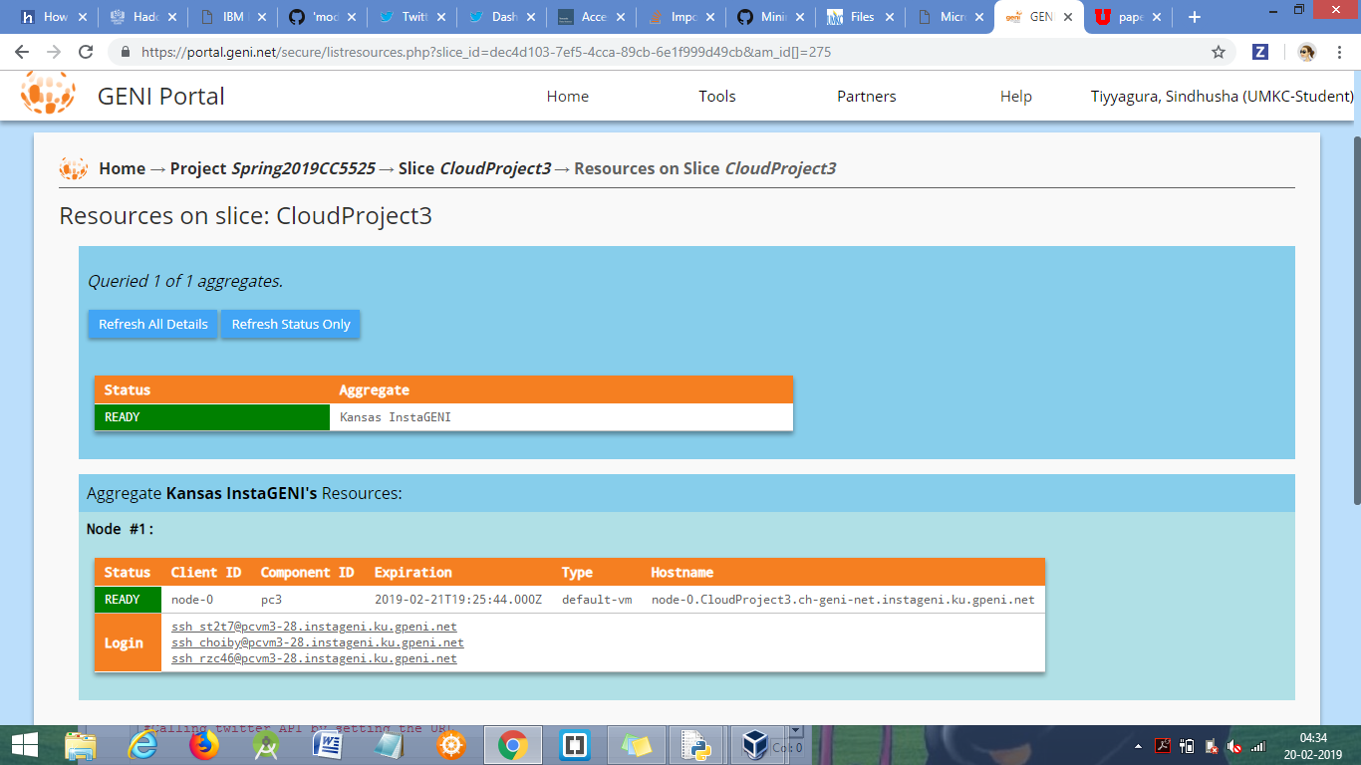

d) Downloaded putty keys to get access to the cloud server from the local machine.

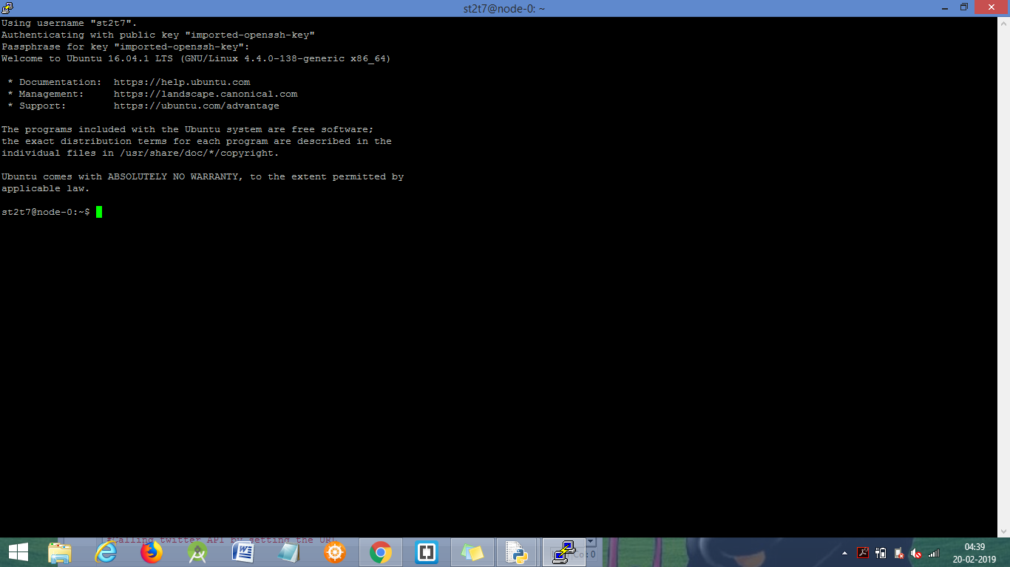

2) Getting access to CloudLab:

a) Logging into CloudLab site using GENI authorization.

b) Starting a new experiment in CloudLab by choosing the resource ( Utah )

c) Getting access to the server.

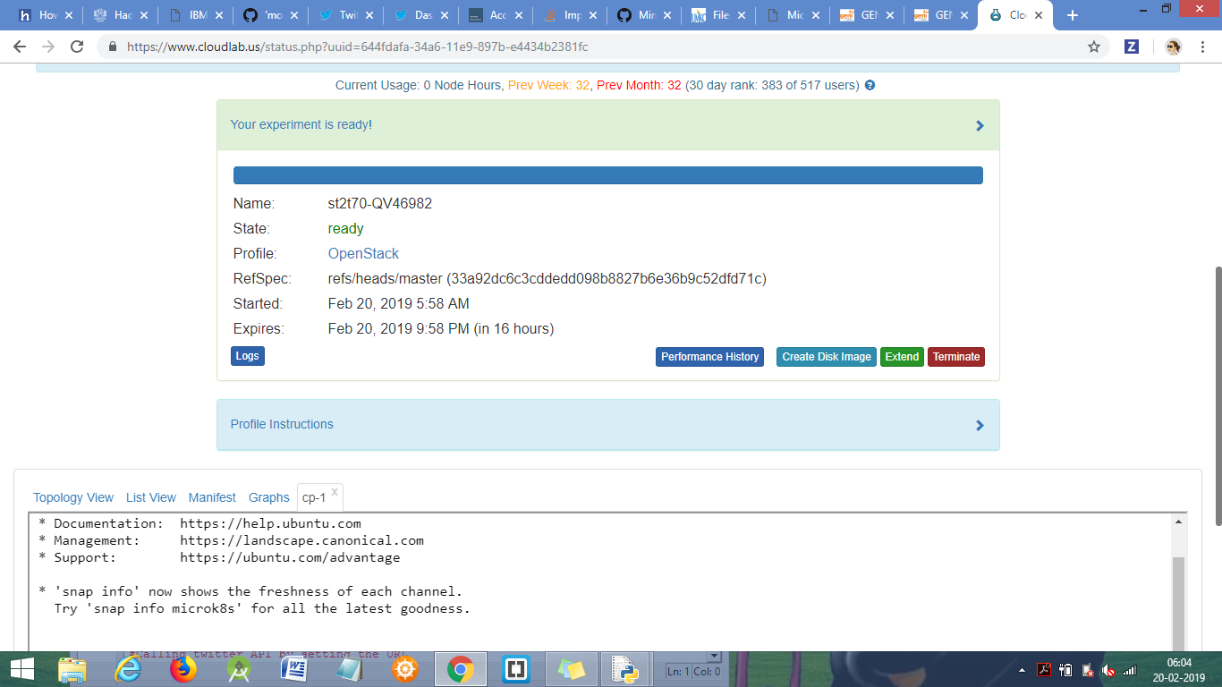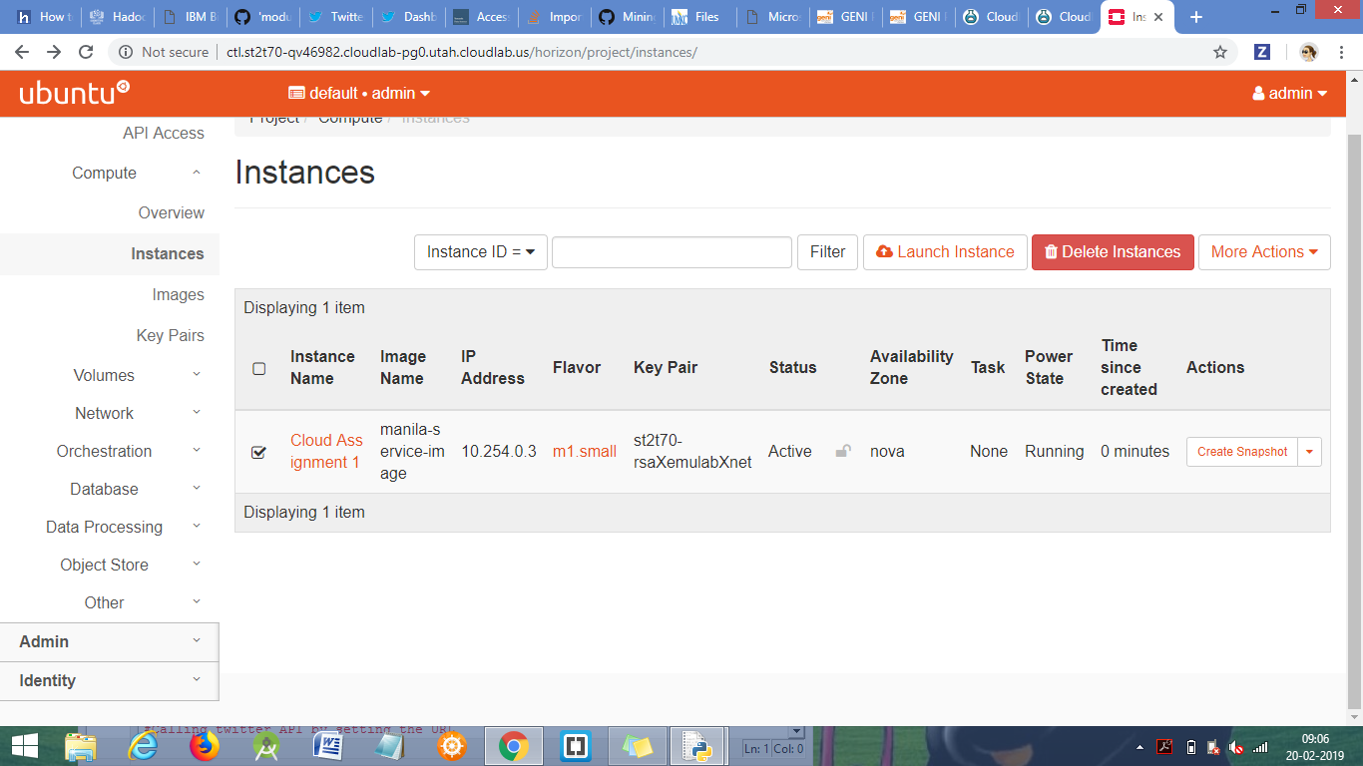

Topological View of the cluster.

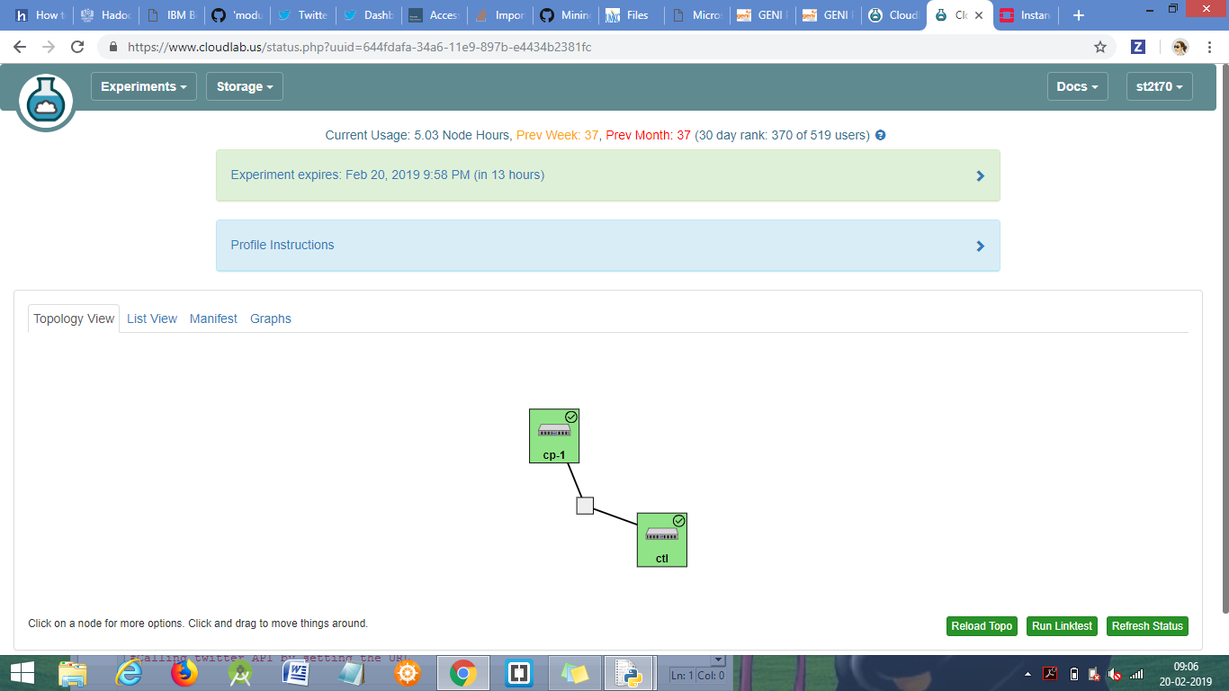

**Task-2:** Steps to deploy a simple web page on the cloud.

1) Installing apache2 on the cloud resource using command sudo apt-get install apache2

2) This creates /var/www/html directories on the server along with a basic index.html page.

3) Modifying index.html page with the required contents.

**USING GENI**

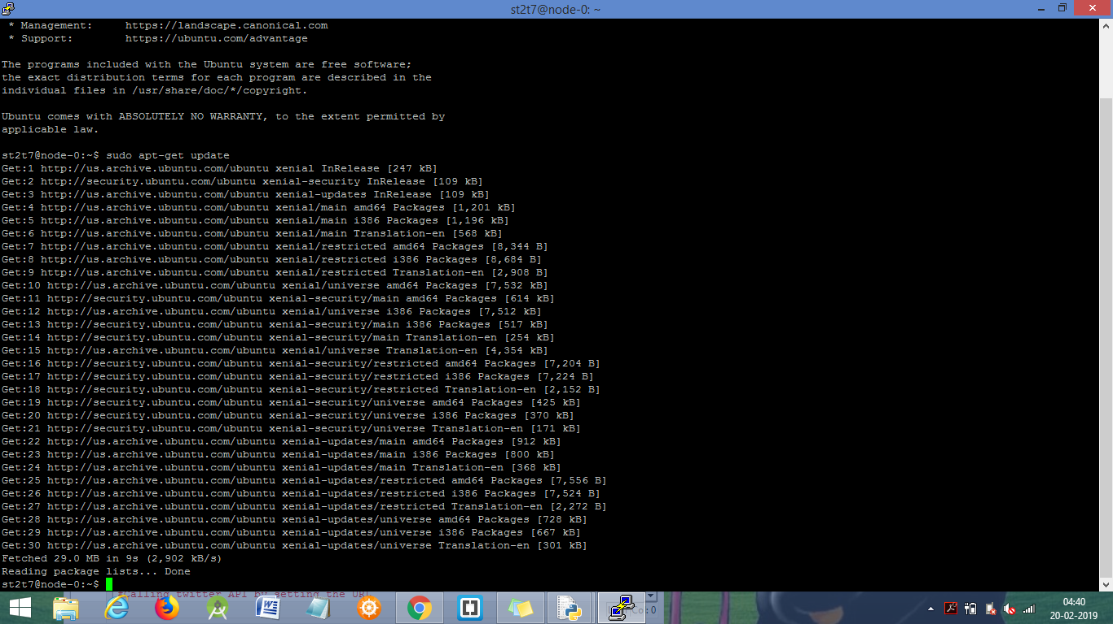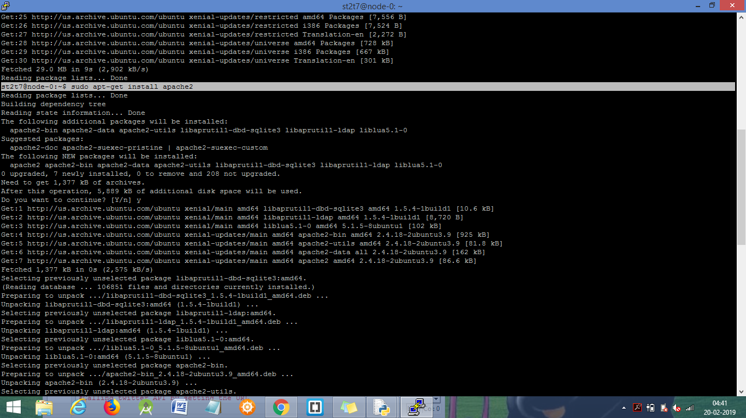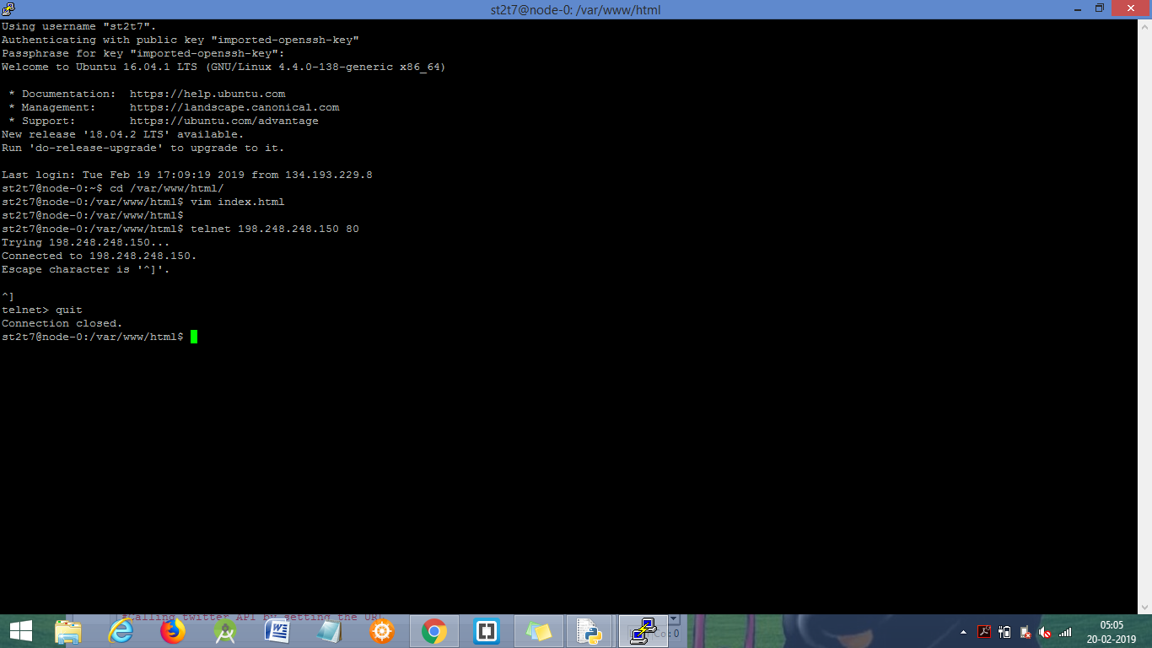

**USING CLOUDLAB:**

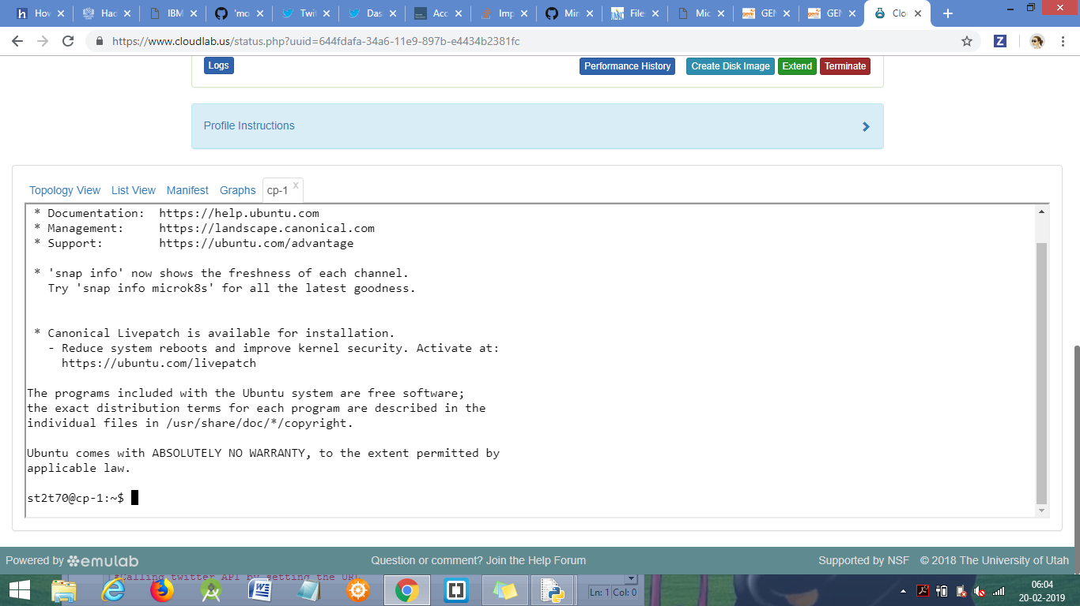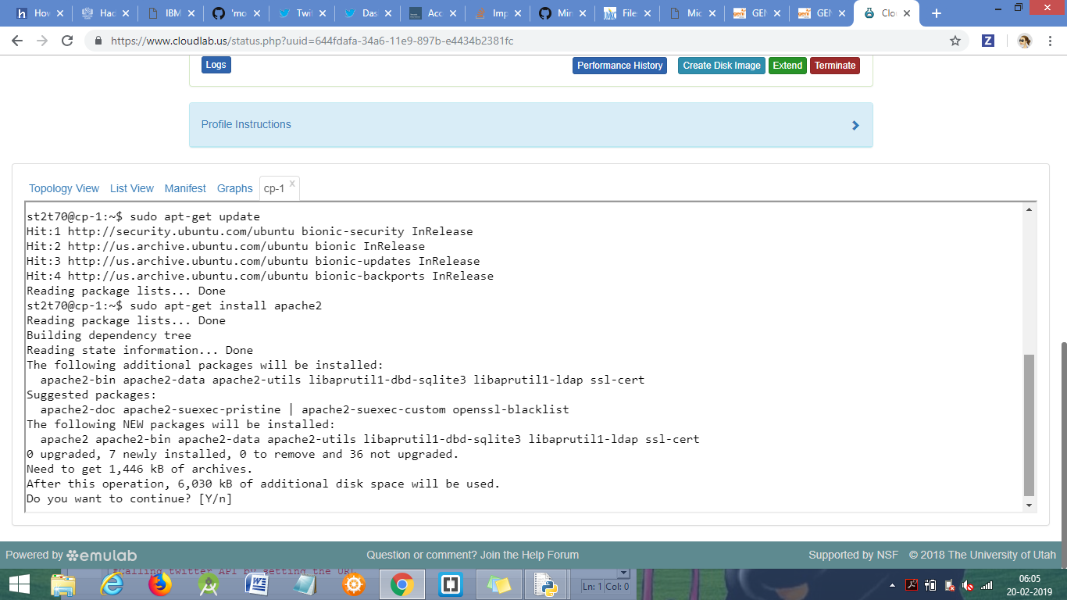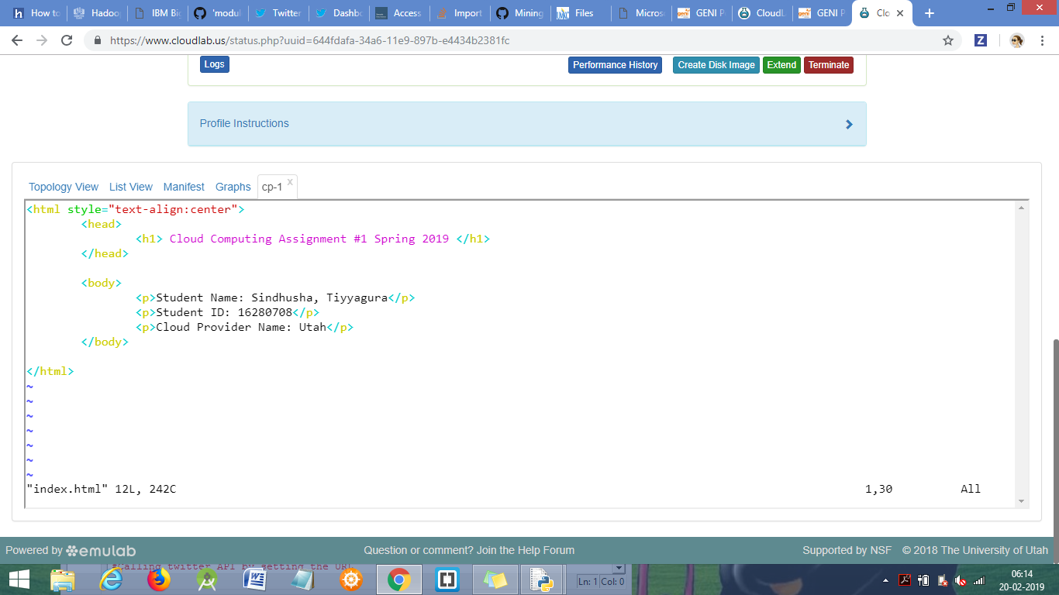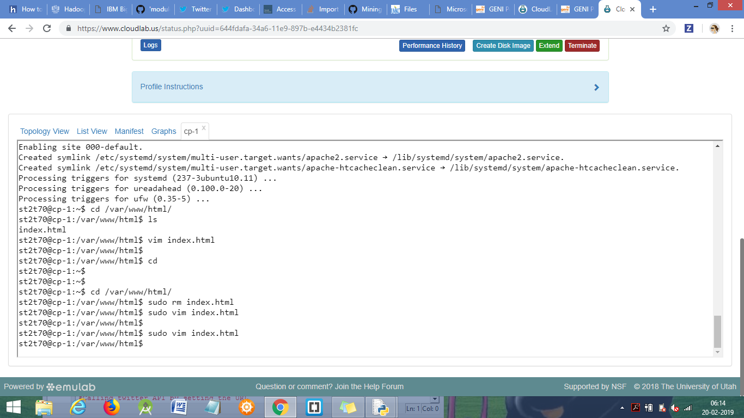

**Task-3: Showing the execution of the web page from the local web browser.**

1) On connecting to the server on port 80( HTTP port number), the web service will be displayed on the local machine.

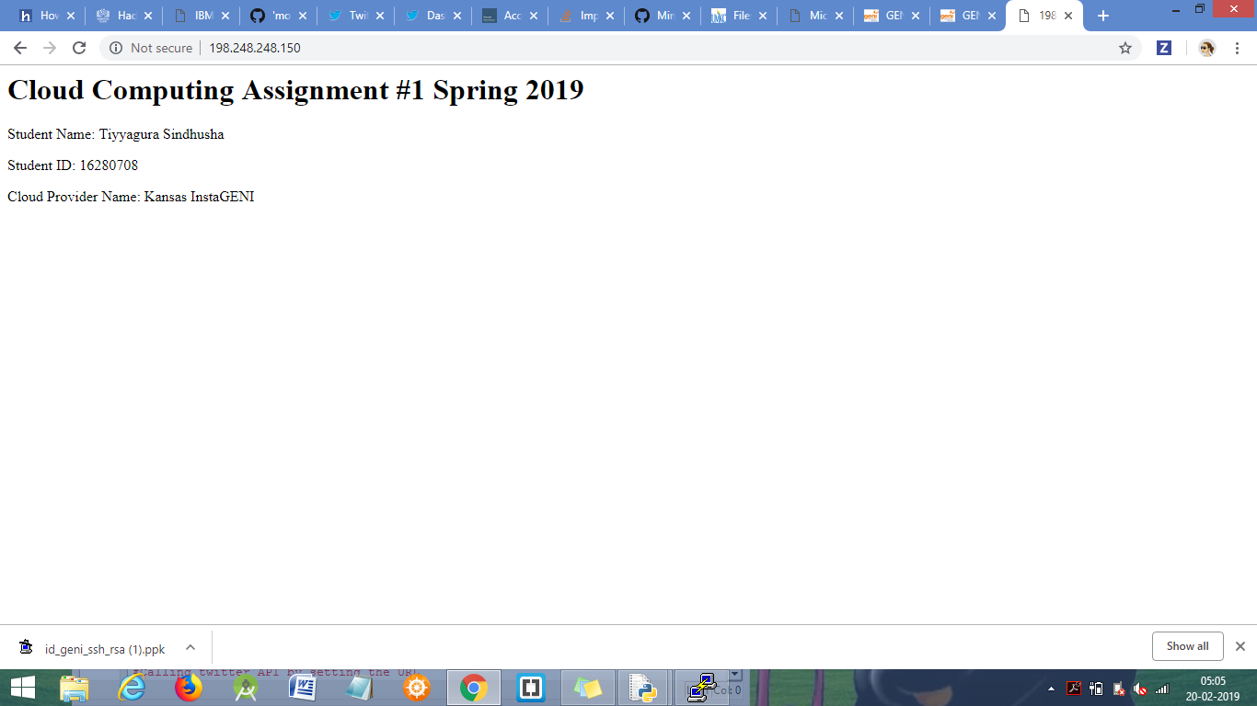

**Task-4:** Describe 1) lessons learnt, 2) fun/difficult parts, 3) comparisons between GENI and CloudLab.

**1) Lessons Learnt:**

I have learnt how to use GENI and CloudLab, creating, reserving and using the resources, connecting to the resources from the local machine.

I have learnt deploying the web services on the cloud.

**2) Fun/difficult parts:**

Fun part: Viewing the web page on the local machine that is deployed on the cloud server without facing any issues in GENI.

Difficult part: I tried deploying the web page on CloudLab but couldn’t see the page on execution. I went over so many documentations but couldn’t figure out the reason.

I am opening an HTTP port to the IP address but my local machine could not connect to the server via HTTP.

**3) Comparisons between GENI and CloudLab:**

1) GENI has lot more types of resources available to choose from compared to CloudLab.

2) Getting resource ready is little fast in GENI compared to CloudLab. Moreover this assumption might be false as this could depend on number of user using the same resources.

3) It is easy to deploy web page in GENI compared to CloudLab.

4) I feel GENI is more secure than CloudLab ( as GENI using ssh keys to connect to the server whereas in CloudLab, one can directly connect to the server using randomly generated passwords.)

5) CloudLab list the available resources graphs on cloud infrastructure like Volumes, CPUs, RAM.